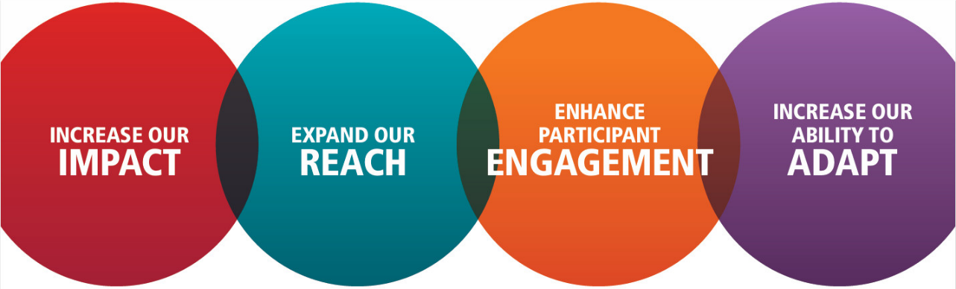

Increase our impact

Your club is a 40-year old club with 18 members in a regional hub. It is well organised and hosts enjoyable meetings. You run two major fundraisers each year and donate the proceeds to local charities.

The club recently attracted two younger members, but they left shortly after, citing their membership goals were not met.

- Why is this happening? What is the cause?
- Suggest 3 strategies that may help

Expand our reach

Your club is a successful 50-year-old club with over 35 members. It has a mental health project and schoolbook donation program. Your fortnightly meeting includes interesting guest speakers. Members enjoy the fellowship.
Very few prospective members visit your club or volunteer on projects.
- Why is this happening? What is the cause?
- Suggest 3 strategies that may help

Enhance participant engagement

The average age of your club is 65+ and membership is steadily declining. You’re located in a small farming community where many younger residents leave for cities.

Prospective members find it difficult to attend meetings or pay club dues. They are interested in gaining skills and giving back. Long serving members appear despondent.
• Why is this happening? What is the cause?
• Suggest 3 strategies that may help

Ability to adapt

Rose is a prospective member who has been volunteering on your club’s health education programs.
She is a busy professional who travels for work and has a small child. Your club meets weekly, face to face, for dinner with a speaker.
Rose wants to join but is reluctant.
• Why is this happening? What is the cause?
• Suggest 3 strategies that may help

