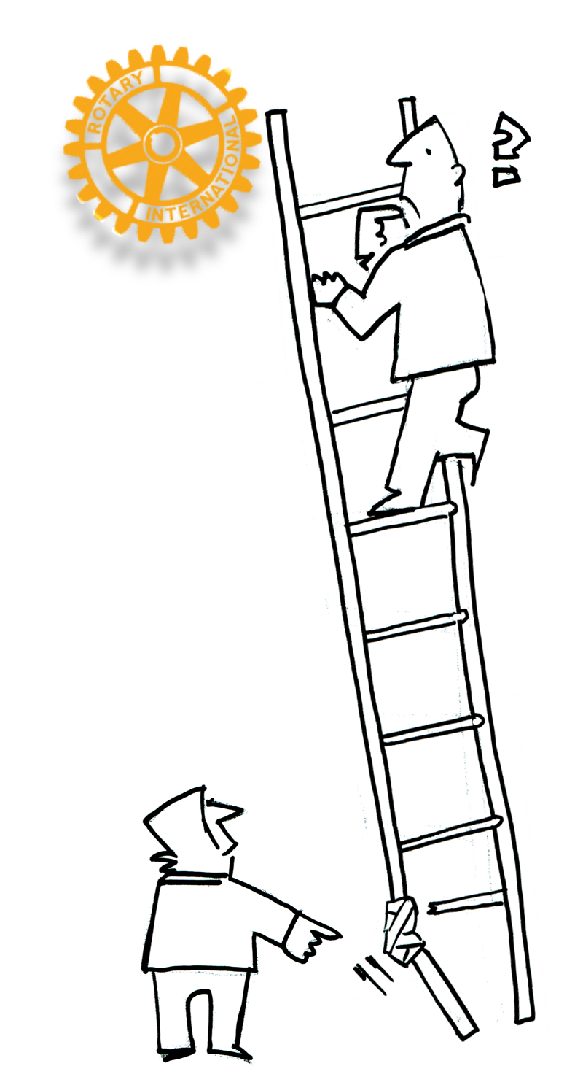

RISK MANAGEMENT MANUAL
ROTARY INTERNATIONAL
DISTRICT 9940 INC
UPDATE 17 January 2018

RISK MANAGEMENT PROCESS

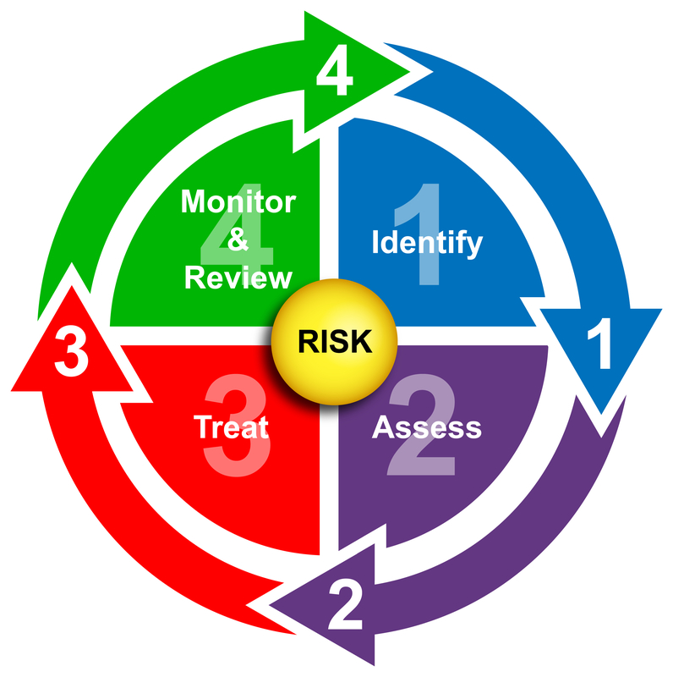

Copyright Dreamstime Inc. www.dreamstime.org

SETTING UP A PROJECT OR ACTIVITY FILE
The following may assist Rotary members in setting up a Project/Activity file
Even though much of the work can be computer based, a hard copy file is essential for good project management.
Use an A4 hard backed folder with a set of say 10 dividers
Division 1 The contents page is where you basically keep a list of all documents in the folder and their latest issue reference.
Division 2 This has information on the Activity, what it is, where it is located, and as much information about the project so that someone reading it would understand it. See suggested format RM 001
Division 3 Keep the hard copy of your risk assessment pages here RM 002
Division 4 If you are going to use the ‘Risk Control Action Record’ RM 003 keep copies of them in this division.
Division 5 Keep in this section a full contact list of all the stakeholders. Describe their relationship to the project, what arrangements are in place re payment or donations etc., or what care is needed or consideration is necessary. See suggested format RM 004
Division 6 List here the specific outcomes that your committee or Rotary wants from the Activity. This can be monetary, goodwill, friendship or anything else. It is the reason you are doing it in the first place. See suggested format RM 005
Division 7 Print off hard copies of the Likelihood and Consequence Tables and the Risk Matrix and keep here for quick reference.
Division 8 It may be appropriate to write a report on the activity when the project is complete or complete for that year. Keep that in this folder, so full use can be made of the experience gained from the successful (or otherwise) completion of the project.
Use other divisions to keep any other relevant documents associated with the Activity / Project.

Project/Activity Information Sheet RM001
Project Owner……………………………………………………………………………………………………………………………………………………………………
Name of Project: …………………….…………………………………………………………………………………………………………………………….
Description of Project: ………….…………………………………………………………………………………………………………………………………………
…………………………………………………………………………………………………………………………………………………………………………………………
What are the dates or Timing of the Project?………………………………………………………………………………………………………………….
Where will the project take place?................................................................................................................... …………
…………………………………………………………………………………………………………………………………………………………………………………………
………………………………………………………………………………………………………………………………………………………………………………………….
Other Information or comments……………………………………………………………………………………………………………………………………….
……………………………………………………………………………………………………………………………………………………………………………………….…
……………………………………………………………………………………………………………………………………………………………………………………….…
……………………………………………………………………………………………………………………………………………………………………………………….….
………………………………………………………………………………………………………………………………………………………………….........................
…………………………………………………………………………………………………………………………………………………………………………………………..
……………………………………………………………………………………………………………………………………………………………………………………….…
……………………………………………………………………………………………………………………………………………………………………………………….…
……………………………………………………………………………………………………………………………………………………………………………………….…
……………………………………………………………………………………………………………………………………………………………………………………….….
………………………………………………………………………………………………………………………………………………………………….........................
…………………………………………………………………………………………………………………………………………………………………………………………..
……………………………………………………………………………………………………………………………………………………………………………………….…
……………………………………………………………………………………………………………………………………………………………………………………….…
……………………………………………………………………………………………………………………………………………………………………………………….…
……………………………………………………………………………………………………………………………………………………………………………………….…
……………………………………………………………………………………………………………………………………………………………………………………….….
………………………………………………………………………………………………………………………………………………………………….........................
…………………………………………………………………………………………………………………………………………………………………………………………..
……………………………………………………………………………………………………………………………………………………………………………………….…
………………………………………………………………………………………………………………………………………………………………………………………………

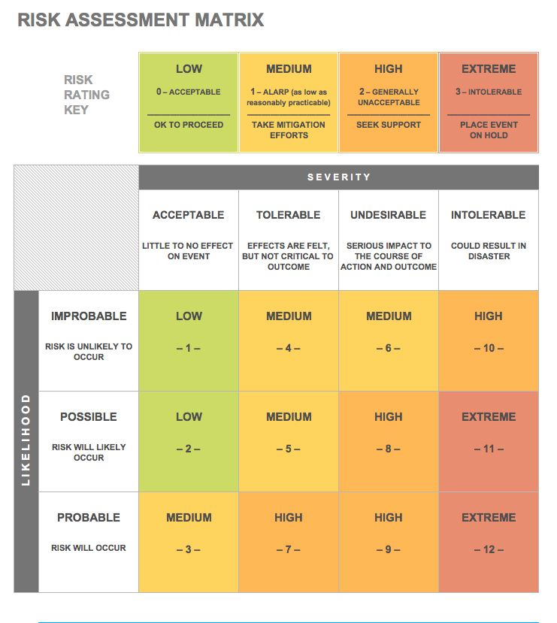

Copyright: Smartsheet Inc USA, www.smartsheet.com
RISK ASSESSMENT RM002

Club/District Project ............................................................. Project ……………………………………… ………………………………………... Date…………………... ASSESSMENT RM002
Likelihood Rating, C = Consequence rating
Ref No | Task | Risk | Potential Harm | Risk Type L C |  | Risk Level | Method of Risk Management
RISK CONTROL ACTION RECORD RM003
TASK REF ………………..
District Committee / Club ………………………………………………. Project / Activity ……………………………
Project Manager ……………………………………………. Date …………….………………………...
Insert task line from Risk Assessment Sheet for all High and Extreme Risks.(Use 1 Task per page and save under task ref no.)

Ref no | Task | Risk | Potential Harm | Risk Type  L C |  | Risk Level | Method of Risk Management
List Specific Action Steps taken (or to be taken) to reduce risk to acceptable level: -
Ref No | Action Steps | Who by | Comments
1
2
3
Project / Activity Manager………………………… Date…………
Approved by …………………………………….. Date………… Rotary Position………………………………………… Review Date ……………………

PROJECT STAKEHOLDERS RM 004

Project Description: …………………………………………………………………………………………………………………………………………………
List ALL the stakeholders and describe their relationship to the project…………………………………………………………………..
…………………………………………………………………………………………………………………………………………………………………………………
…………………………………………………………………………………………………………………………………………………………………………………
………………………………………………………………………………………………………………………………………………………………………………….
…………………………………………………………………………………………………………………………………………………………………………………
…………………………………………………………………………………………………………………………………………………………………………………
…………………………………………………………………………………………………………………………………………………………………………………
…………………………………………………………………………………………………………………………………………………………………………………
…………………………………………………………………………………………………………………………………………………………………………………
…………………………………………………………………………………………………………………………………………………………………………………
………………………………………………………………………………………………………………………………………………………………………………….
Who has overall responsibility? ....................................................................................................................................
…………………………………………………………………………………………………………………………………………………………………………………
Who will manage the project? ......................................................................................................................................
…………………………………………………………………………………………………………………………………………………………………………………
………………………………………………………………………………………………………………………………………………………………………………..
Who will help? ………………………………….……………………………………………….…………………………………………………………………….
………………………………………………………………………………………………………………………………………………………………………………..
………………………………………………………………………………………………………………………………………………………………………………..
…………………………………………………………………………………………………………………………………………………………………………………
…………………………………………………………………………………………………………………………………………………………………………………
………………………………………………………………………………………………………………………………………………………………………………….
…………………………………………………………………………………………………………………………………………………………………………………
…………………………………………………………………………………………………………………………………………………………………………………
Who will benefit?.......... ...............................................................................................................................................
…………………………………………………………………………………………………………………………………………………………………………………
…………………………………………………………………………………………………………………………………………………………………………………
…………………………………………………………………………………………………………………………………………………………………………………
…………………………………………………………………………………………………………………………………………………………………………………
…………………………………………………………………………………………………………………………………………………………………………………
……………………………………………………………………………………………………………………………………………………………………………….

Who will be consulted? ……………………………………………………………………………….…………………………………………………………..
……………………………………………………………………………………………………………………………………………………………………………
………………………………………………………………………………………………………………………………………………………………………………….
…………………………………………………………………………………………………………………………………………………………………………………..
…………………………………………………………………………………………………………………………………………………………………………………..
Are Govt or Local Govt people involved? …………………………………………….………………………………………………………………………
Who could be affected?.................................................................................................................................................
………………………………………………………………………………………………………………………………………………………………………………..
…………………………………………………………………………………………………………………………………………………………………………………
…………………………………………………………………………………………………………………………………………………………………………………
………………………………………………………………………………………………………………………………………………………………………………..
………………………………………………………………………………………………………………………………………………………………………………….
………………………………………………………………………………………………………………………………………………………………………………..
…………………………………………………………………………………………………………………………………………………………………………………
Who will participate?.....................................................................................................................................................
…………………………………………………………………………………………………………………………………………………………………………………..
…………………………………………………………………………………………………………………………………………………………………………………..
…………………………………………………………………………………………………………………………………………………………………………………
……………………………………………………………………………………………………………………………………………………………………………….
…………………………………………………………………………………………………………………………………………………………………………………
…………………………………………………………………………………………………………………………………………………………………………………
…………………………………………………………………………………………………………………………………………………………………………………
…………………………………………………………………………………………………………………………………………………………………………………
Keep contact details of stakeholders………………………………………………………………………………………………………………………..
…………………………………………………………………………………………………………………………………………………………………………………..
…………………………………………………………………………………………………………………………………………………………………………………..
……………………………………………………………………………………………………………………………………………………………………………………
…………………………………………………………………………………………………………………………………………………………………………………
…………………………………………………………………………………………………………………………………………………………………………………
…………………………………………………………………………………………………………………………………………………………………………………
………………………………………………………………………………………………………………………………………………………………………………….
………………………………………………………………………………………………………………………………………………………………………………….
…………………………………………………………………………………………………………………………………………………………………………………
………………………………………………………………………………………………………………………………………………………………………………..

PROJECT OUTCOMES RM 005

List the Outcomes required for the project to be a success: ………………………………………………………………… ………………….
…………………………………………………………………………………………………………………………………………………………………………………
…………………………………………………………………………………………………………………………………………………………………………………
…………………………………………………………………………………………………………………………………………………………………………………
…………………………………………………………………………………………………………………………………………………………………………………
…………………………………………………………………………………………………………………………………………………………………………………
Primary reason for carrying out the project……………………………………………………………………………………………………………..
………………………………………………………………………………………………………………………………………………………………………………….
…………………………………………………………………………………………………………………………………………………………………………………
…………………………………………………………………………………………………………………………………………………………………………………
…………………………………………………………………………………………………………………………………………………………………………………
…………………………………………………………………………………………………………………………………………………………………………………
…………………………………………………………………………………………………………………………………………………………………………………
Also consider the following:-…………………………………………………………………………………………………………………………………….
Monetary Personal Growth Friendships, Community help, Goodwill ............................................…………………………….
…………………………………………………………………………………………………………………………………………………………………………………
…………………………………………………………………………………………………………………………………………………………………………………
…………………………………………………………………………………………………………………………………………………………………………………
…………………………………………………………………………………………………………………………………………………………………………………
…………………………………………………………………………………………………………………………………………………………………………………
…………………………………………………………………………………………………………………………………………………………………………………
…………………………………………………………………………………………………………………………………………………………………………………
…………………………………………………………………………………………………………………………………………………………………………………
………………………………………………………………………………………………………………………………………………………………………………….
………………………………………………………………………………………………………………………………………………………………………………….
………………………………………………………………………………………………………………………………………………………………………………….
………………………………………………………………………………………………………………………………………………………………………………….
………………………………………………………………………………………………………………………………………………………………………………….
………………………………………………………………………………………………………………………………………………………………………………….
………………………………………………………………………………………………………………………………………………………………………………….
………………………………………………………………………………………………………………………………………………………………………………….

SECTION 5- EVALUATION CRITERIA
RISK EVALUATION AND DOCUMENTATION
Identifying Risk Levels:
Practical Risk Assessment and management initially involves 7 Stages
Break the activity down into Tasks, these are the things that must be done or the things that will happen when this activity is performed. Some activities may only require 5 tasks other activities will need 30 or more and some of the tasks themselves will need to be further broken down. (Number each task for reference).
Decide on the Risk associated with each of these tasks. Some Tasks may have more than one risk. If there appear to be many Risks then it may be necessary to break the task up further.
For each Risk Factor there is a Potential Harm. Decide on what the potential harm might be if that risk materialised.
Using the Consequences Table, rate the risk in terms of the damage it might do if the Potential Harm from the task actually occurred.
Using the Likelihood table, now rate the risk in terms of the chances of it actually happening.
The Level of Risk Matrix will now show a rating of the level of risk. This process is subjective but with practice it will consistently highlight areas that may need special attention.
Once the level of risk has been assessed for all the tasks, it is recommended that those in the Extreme and High category receive further management attention using the Risk Control Action Record - RM 003.
The Risk Response Strategies table provides guidance for options to TAKE, TERMINATE, TRANSFER or MITIGATE the risk. Whilst MITIGATION in some manner will be the probable active option serious consideration needs to be given to the other three T’s.
When looking at Risk and Potential harm, consider using a ‘What If’ analysis and ask the questions,
“W HAT CAN HAPPEN?” AND “HOW CAN IT HAPPEN?”
When dealing to significant risks, the objective should always be to manage the risk such that it is
AS LOW AS REASONABLY PRACTICAL

REDUCING RISK: MANAGEMENT ACTION: HIERARCHY OF CONTROLS
Example
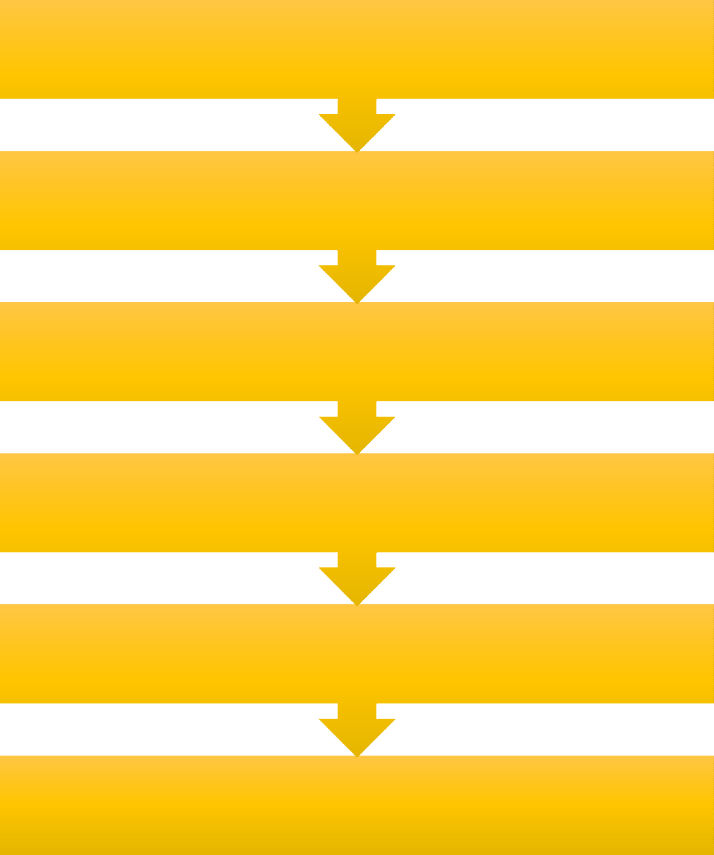
(EL) Eliminate hazard (Get Rid Of)

The risk of a fall from height by doing all work at ground level. | The risk of exposure to a hazardous substance by disposing of any unwanted chemicals. | The risk of a trip by keeping all floor surfaces clear and level.

  - Substitute the hazard with something safer (Replace)

Replace old equipment with more modern equipment

Replace a chemical with a safer one.

    - Isolate hazard from person (Barrier/Distance)

Store chemicals in a locked DG cabinet | Cover noisy equipment. | Move equipment away from people. | Install guardrails to seperate workers from moving plant.

(EN) Engineering controls

Place guards around moving parts of machinery. | Use trolleys or hoists to move heavy loads. | Extraction and monitoring equipment for fumes and dust.
      - Administrative controls

Policy, procedures, processes, safe method statements | Training and supervision. | Monitoring, housekeeping and testing/audits. | Safety and warning signs, beepers, beacons etc.
(P) Use PPE

Protective clothing and equipment like safety glasses, hard hats safety boots, hi-viz vests etc.

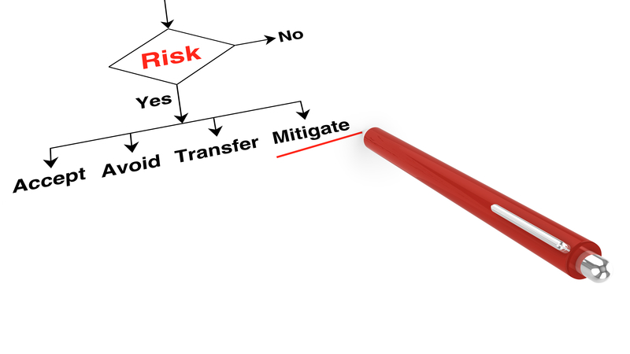

Diagram copyright by Smartsheet Incorpororated.

Project/Activity Information Sheet - Example RM001
Project Owners: ………………………………………………………………………………………………………………………………..
……………………………………………………………………………………………………………………………………………………………
…………………………………………………………………………………………………………………………………………………………..
…………………………………………………………………………………………………………………………………………………………..
…………………………………………………………………………………………………………………………………………………………..
Name of Project: ………………………………………………………………………………………………………………………………
…………………………………………………………………………………………………………………………………………………………..
…………………………………………………………………………………………………………………………………………………………..
…………………………………………………………………………………………………………………………………………………………..
Description of Project: ………………………………………….………………………………………………………………………….
…………………………………………………………………………………………………………………………………………………………..
…………………………………………………………………………………………………………………………………………………………..
What are the dates or Timing of the Project: ..…………………………………………………………………………………
Where will the project take place: …………………………………………………………………………………………………
………………………………………………………………………………………………………………………………………………………..
Other Information or Comments: …………………….……………………………………………………………………………
……………………………………………………………………………………………………………………………………………………….
………………………………………………………………………………………………………………………………………………………..
……………………………………………………………………………………………………………………………………………………….
……………………………………………………………………………………………………………………………………………………….
……………………………………………………………………………………………………………………………………………………….
……………………………………………………………………………………………………………………………………………………….
……………………………………………………………………………………………………………………………………………………….
………………………………………………………………………………………………………………………………………………………..
……………………………………………………………………………………………………………………………………………………….
……………………………………………………………………………………………………………………………………………………….
………………………………………………………………………………………………………………………………………………………..
……………………………………………………………………………………………………………………………………………………….

RISK ASSESSMENT - EXAMPLE RM 002
Club/District Project .............................................................

Project …………………………………………………… Date …………………
L = Likelihood Rating
C = Consequence Rating
Ref No | Task | Risk | Potential Harm | Risk Type L C |  | Risk Level | Method of Risk Management
1 | Notification to Clubs | Wrong Information or forms sent | Rotary members are confused and upset and complain to the DG | D | 1 | Low | Double check all information sent out. One contact person for information
2 | Notification to Schools | Wrong Information or forms sent | Schools withdraw from scheme | D | 2 | Low | Double check all information sent out. One contact person for information
3 | Clubs select interview Team | Person with child abuse or other inappropriate background selected | Injury to Child,  Rotary receives bad press Police investigation | E | 5 | High | Selection Process must be open  Needs to be a background check that is reliable, for all participants
4 | Club selects Councillors | Person with child abuse or other inappropriate background selected | Injury to Child,  Rotary receives bad press Police investigation | E | 5 | High | Selection process must be open  Needs to be a background check that is reliable, for all participants.  Counselor Training to be run by the District

Ref No | Task | Risk | Potential Harm | Risk Type L C |  | Risk Level | Method of Risk Management
5 | Interview of applicants | Interviews not conducted to same standards | Children / families chosen who do not meet the required standards | B | 3 | High | Format of interviews to be produced with question guidelines. Specific Standards to be acknowledged
6 | Final selection of candidates | Bias result, best child not chosen | Complaint to District Members unhappy  No match for selected child Exchange does not work out | C | 2 | Med | Selection process open amongst panel. Result put to club before child informed. President or other non involved person to check procedure and sign off
7 | Names and information forwarded to district com. | Information is not complete or not correct. | Deadline missed Child not selected  Injury or Illness due to wrong or missing info. | C | 3 | High | Training of club coordinators Use of form index Double check medical requirements
8 | Matching candidates | Trans Tasman Interviews not conducted to same standards | Inappropriate matching, child(ren) unhappy returns home early. | B | 3 | High | Common guidelines to be adopted Thorough process of selection with triple checks.

Ref No | Task | Risk | Potential Harm | Risk Type L C |  | Risk Level | Method of Risk Management
9 | Notification to children and Parents | Parents find out at different times | Parents Unhappy with process. | C | 2 | Med | Process for ensuring notification is at same time.
10 | Orientation | Poor presentation Issues not properly discussed | Rotary discredited Inappropriate behavior by some students not highlighted or properly resolved. | D | 3 | Med | Good preparation use previous format and experienced people.  Ensure ALL students understand and sign on to the required code of Conduct.
11 | Issue Travel documents | Over complicated or hard to understand  Incorrect | Student Parents lose confidence in Rotary. | D | 3 | Med | Keep to what works, keep it simple.
12 | Meet the Sponsoring Rotary Club | Club seen as unfriendly | Loss of confidence Rotary | D | 3 | Med | Plan for warm welcome
13 | Assemble at airport | Student arrives late Student refuses to leave Student has no passport Student has hidden Drugs | All reflects poorly on Rotary organisation | D | 4 | High | Plan to meet early, have cell phone contact with each family group.  Discuss homesickness with families. Families to have check list of essential items  Ensure all students and families understand implications of 3 D’s Police check the students?

Ref No | Task | Risk | Potential Harm | Risk Type L C |  | Risk Level | Method of Risk Management
14 | Keeping in touch with NZ  Student | Student feels isolated form Rotary support. Student has a serious problem. | Student unable to deal with potential problem.  Student may be at risk | D | 4 | High | Develop a code for Students to use with their counsellors, when they need help.
15 | Meeting students on return to NZ | Rotary not visible to Students and families on return.  Aust Students feel there is no Rotary support. | Families lose confidence in Rotary. Early bond not made with Aust Students. | D | 3 | Med | Have as many counsellors as possible at Airport, plus other Rotary members, from the Wellington Clubs
16 | Aust Student First night with NZ Councilor | Aust Student feels threatened by situation. | Accusations made against Counsellor  Rotary Club Rotary District | D | 4 | High | Clear Communications.  Advance warning of arrangements Gender balance maintained at all times
17 | Keeping in touch with the Aust Student | Student hears from Counsellor infrequently and in appropriately | Problems are not discussed or resolved, reflects badly on Rotary. May involve a serious problem | C | 4 | Extreme | Clear guidelines set by District for communications. Random checks to see process working.  Serious Issues notified up chain.
18 | Aust Student to school | School environment not suitable for student. | Student becomes Isolated, threatened or at risk. | D | 3 | Med | Communications between Student  Counsellor and school must be open and regular. Serious issues notified up chain.

Ref No | Task | Risk | Potential Harm | Risk Type L C |  | Risk Level | Method of Risk Management
19 | Acclimatise to NZ life | Student does not fit in becomes isolated. | Student becomes Isolated, threatened or at risk. | D | 4 | High | Communications between Student Counsellor and school must be open and regular. Serious issues notified up chain.
20 | Safari | AccidentInvolved in an assault Goes missing | Personal InjuryStress to minders / Family Rotary criticised | D | 5 | Extreme | Separate Management plan required for safari.Activities MUST be professionally organised and run.
21 | Visit to Sponsoring Rotary Club | Student not expected or made welcome.  . | Rotary seen in poor light Student does not want to re- visit. | D | 3 | Med | Student kept fully informed on what is required and when.
22 | Presentation to the Rotary Club | Student has not prepared an address | Student embarrassed gives poor presentation | C | 3 | High | Counsellor helps or ensures student is prepared prior to meeting
23 | Dealing with issues. | Issues that arise are not resolved or rectified. | Student at risk of: - Personal Harm Loss of privacy Feeling Isolated  Material losses | C | 4 | Extreme | Rotary to ensure that the program has sufficient safeguards and reporting requirement so that good communications and problem solving is always available.
24 | Departure | Student arrives late Student has no passport | All reflects poorly on Rotary organisation | D | 4 | High | Plan to meet early, have cell phone contact with each family group. Families to have check list of essential items
25 | Finalisation | Same problems occur each year | Loss of enthusiasm for exchange | D | 3 | Med | Committee to review each program and incorporate issues resolved or otherwise into planning.

RISK CONTROL ACTION RECORD - EXAMPLE RM 003
TASK REF …………..
District Committee / Club ………………………………………………. Project / Activity ……………………………………………… Project Manager ……………………………. Date ……………………..
Insert task line from Risk Assessment Sheet for all High and Extreme Risks.(Use 1 Task per page and save under task ref no.)

Ref no | Task | Risk | Potential Harm | Risk Type L C |  | Risk Level | Method of Risk Management
17 | Keeping in touch with the Aust. student | Student hears from the Counsellor infrequently and inappropriately | Problems are not discussed or resolved, reflects badly on Rotary. May involve a serious  problem. | C | 4 | Extreme | Clear guidelines set by District for communications. Random checks to see process working. Serious issues notified up the chain.
List Specific Action Steps taken (or to be taken) to reduce risk to acceptable level: -

Ref No | Action Steps | Who by | Comments
1 | Draw up guidelines for communications, including reporting and checks by end September 2003. | John D | Ref Document Guidelines Matched Exchange 2003
2 | Issue referred document to all counsellors and host parents at training November 2003 | Marion P | Add to kit list
3 | Add question on communications to student de-briefing questionnaire | John D | Review at the next meeting date ………………
Project / Activity Manager………………………… Date…………
Approved by …………………………………….. Date………… Rotary Position………………………………………… Review Date ……………………

The following diagram and the Safety Hazard Management Checklist will aid the process. It is important that all persons involved in the project are briefed and personally acknowledge the safety risks.

Copyright Copyright:-
Copyright Dreamstime Inc. www.dreamstime.org

SAFETY HAZARD MANAGEMENT CHECKLIST
PROJECT: ……………………………………………..…………. SITE LOCATION: …………………….………………….…

Date: ………….. Project Leader: …………………………….. Deputy Leader: …………………………………….
A HAZARD IS ANYTHING THAT CAN CAUSE HARM TO YOU, OTHER WORKERS ON SITE, THE PUBLIC OR THE ENVIRONMENT. LOOK AT THE JOB YOU ARE DOING AND CONSIDER THE FOLLOWING THINGS THAT MAKE UP YOUR WORK.
IDENTIFIED HAZARD | IDENTIFIED RISKS | RISK RATING | HAZARD CONTROL | ACTION TO ELIMINATE OR MINIMISE
Example  Road Traffic: | Road Users being confused by poor traffic management | High | Mit | Provide an alternative safe pedestrian walkway

IDENTIFIED HAZARD | IDENTIFIED RISKS | RISK RATING | HAZARD CONTROL | ACTION TO ELIMINATE, ISOLATE OR MINIMISE
PROJECT PERSONNEL / VOLUNTEER ACKNOWLEDGEMENT

Name | Date | Personal Protection Equipment Issued |  | Site induction complete |  | I have read and understood the hazards and implemented the actions listed
 |  |  |  | YES | NO | SIGNATURE

CONSENT FOR DISCLOSURE OF INFORMATION

DISTRICT COMMITTEE;……………………………………………………………………….. ROTARY CLUB OF;……………………………………………………..
The Manager
Licensing & Vetting Service Centre PO Box 3017 WELLNGTON
(Surname)……………………………………………………………. (First Names)………………………………………………………………………………..
(Maiden or any other names used)……………………………………………………………………………………………………………………………….
Residential Address……………………….........................................................New Zealand Driving License number………….....
Hereby consent to the disclosure by the New Zealand Police of any information they might have pursuant to this application to:- Either: - The Chairman, Rotary District 9940 Committee …..……………………..……………………
Or: - The President, The Rotary Club of ……..…………………………………………………………………….
Signed ………………………………………………………… Date ………………………………
COMMENTS OF THE NEW ZEALAND POLICE:-……………………………………………………………………………………………………………….
…………………………………………………………………………………………………………………………………………………………………………………….
……………………………………………………………………………………………………………………………………………………………………………………..
……………………………………………………………………………………………………………………………………………………………………………………..
……………………………………………………………………………………………………………………………………………………………………………………..
……………………………………………………………………………………………………………………………………………………………………………………..
POLICE VETTING

For more detail please refer to this link;
http://www.police.govt.nz/sites/default/files/publications/nzpvs-cost-recovery-guide.pdf

QUESTIONS AND THE RECOMMENDED LIKELY ENTITY ACTION

1. | Does proposed project create possible financial risk? | Higher risk Lower risk | Form a separate legal entity to run project Consider insurance options  Should yourun theproject? Run project through your club | - Separate legal entity  - Trust  - Company  - Incorporated Society  - Incorporated Society (club)
2. | What will be the projected total income from all sources  – Subscriptions, raffles, projects? | Under  $40,000  Over $40,000 but under $80,000  Over $80,000 | All activities including projects can be conducted through yourclub  You have the option of separating your club activities from projects to keep both under GST threshold  Maystillbepossibletokeeponeofyourclubor your trust under GST threshold | - Incorporated Society (club)  - Incorporated Society (club) and Charitable Trust (projects)  - IncorporatedSociety(club)and Charitable Trust (projects)
3. | Will you be holding accumulated funds on deposit which will earn more than  $1,000 per annum interest? | Yes  No | Hold in Trust as exempt from tax  Can be held by club but will needto file a tax return to obtain tax refund (if any) | - Charitable Trust  - Incorporated Society (if prepared to seek tax refund) otherwise Charitable Trust

QUESTION |  | RECOMMENDED ACTION
Will you be distributing ALL project funds each tax year? | Yes  No | Project could be run by club or trust (dependingonrisk)  Project could be run by club or trust (depending on risk) but club must transfer any undistributed funds to trust before end of tax year to avoid  paying income tax on retained funds
Will you be remitting funds to The Rotary Foundation or overseas projects? | Yes | Such funds must be remitted by either your club or your trust via The  New Zealand Rotary Clubs Charitable Trust

REFERENCES AND ACKNOW LEDGEMENTS
Rotary District 9940 would like to acknowledge the following organisations and their documentation that have been of invaluable help in preparing this manual.

- Worksafe New Zealand worksafe.govt.nz/worksafe,
- Rotary New Zealand World Community Service (RNZWCS Limited) https://www.rnzwcs.org/resources
Downloadable resources for New Zealand Rotarians, partners, volunteers and others.
- New Zealand Police, Licensing and Vetting Service Centre
- http://www.police.govt.nz/about-us/publication/police-vetting-forms eg
- Vetting Procedure Guidelines
- Criminal Record requests
- New Zealand Federation of Voluntary Welfare Organisations manual
- RISK MANAGEMENT Managing Legal Risks for Voluntary Organisations
- http://www.worldcat.org/title/risk-management-managing-legal-risks-for- voluntary-organisations/oclc/1
- Sports New Zealand
- Sport NZ Risk Management of Events guidelines and templates:-
o http://www.sportnz.org.nz/managing-sport/search-for-a-resource/guides/risk- management-for-events
- Sports NZ Enterprise risk management guidelines for organisations at:-
o http://www.sportnz.org.nz/managing-sport/search-for-a- resource/news/enterprise-risk-management-resource
- Workplace Risk Solutions
o https://www.crombielockwood.co.nz/workplacerisksolutions
- A number of International Rotary web sites.
  - www.rnzwcs.org/resources
  - Particular acknowledgement is made of the input of District 9970
  - NZS/AS IOS 31000:2009 and associated Standards
https://www.standards.govt.nz/
- Smartsheet Inc (US), manual design support
  - www.smartsheet.com
- Dreamstime Inc (US), manual design support
  - www.dreamstime.com

